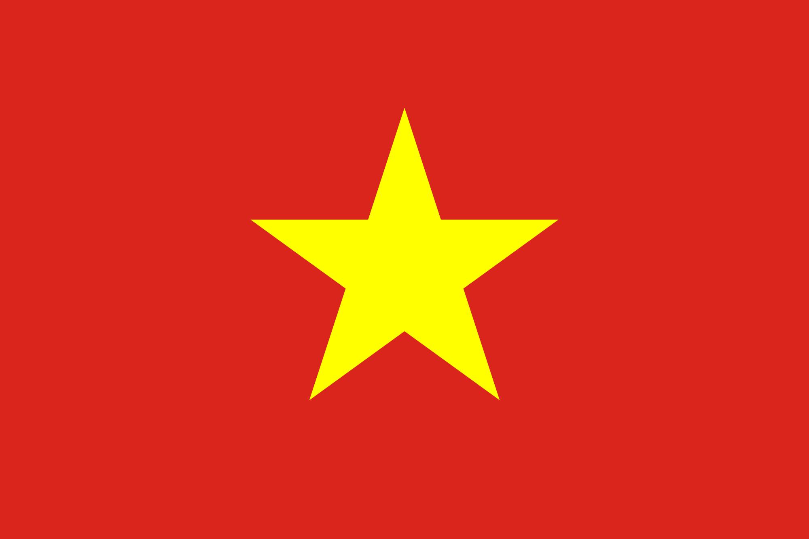

Ministry of Science and Technology Ministry of Science and Technology
State of Israel S.R. Viet Nam

VIET NAM - ISRAEL COOPERATIVE SCIENTIFIC RESEARCH

Call for Proposals

2021-2023

Submission by 10 September 2019

- Areas of Cooperation
The Ministry of Science and Technology of the State of Israel (referred to as "MOST-IL") and the Ministry of Science and Technology of the S.R. Viet Nam (referred to as "MOST-VT") are providing financial support for joint research activities carried out by Vietnamese and Israeli researchers. Vietnamese-Israeli research teams are hereby invited to submit joint research proposals on the following topic:
Diagnosis, treatment and prevention of vector-borne diseases - According to the World Health Organization (WHO) vector-borne diseases account for more than 17% of all infectious diseases. These diseases caused by parasites, viruses and bacteria that are transmitted by the bite of infected arthropod species, such as mosquitoes, mite, ticks, fleas, sandflies, and blackflies. Every year there are more than 700,000 deaths from diseases such as malaria, dengue, Japanese encephalitis, Zika, rickettsiosis, leishmaniasis.... This joint call for proposal aims to develop new diagnostic technologies, therapies and prevention for vector-borne diseases in human..
- Mode of Cooperation

Cooperation may take the form of:
- Joint research activities in which interdependent subprojects of a single project are conducted in the Vietnamese and the Israeli laboratories;
- Complementary methodological approaches to a common problem;
- Joint use of research facilities, materials, equipment and/or services by cooperating scientists;
Submission of joint research projects by researchers of both countries is requested with the aim of encouraging scientific and technological co-operation between Viet Nam and Israel. Each joint research team may submit one project only. Financing will be granted exclusively for joint projects by Vietnamese researchers and Israel researchers.
- Level of Funding
MOST-IL will grant a funding of up to $ 180,,000 per project for 3 years ($60,000 per year) for the Israeli PIs. MOST-VT will grant a maximum funding of $270,000 per project for 3 years (90,000$ per year) for the Vietnamese PIs.
It is the intention of the two ministries to support up to 6 joint projects. However, the final number of projects to be supported will be determined based on scientific merits of the proposals and budgetary considerations. Research projects should be planned on a three year basis.
Funding depends on the approval of the State budget and on the availability of funds in the State Budget of both countries.
Note: This Call is dependent upon joint decisions of both Viet Nam and Israel and is subject to changes and periodic updates with regard to various details.
- Eligibility
1. Projects must be conducted by collaborating Vietnamese and Israeli scientific research teams.
2. Each research team must be led by a Principal Investigator (PI) from each country.
3. The PI must be a member of an academic or research institution or a professor emeritus who continues working on research in academic or research institution (hereinafter called the “Affiliated Institution”);
In Israel, the "Affiliated Institution" must be one of the following:
- An accredited institution of higher learning in Israel, according to the Council for Higher Education Law, 1958;
- A Research Institute recognized as such by the Israel Science Foundation (ISF);
- A Research Institute which is a nonprofit organization;
- A Research Institute which is a government company or a governmental unit.
For the purpose of this Call, a "Research Institute" is a research institute whose significant portion of activity is the advancement of cutting-edge scientific knowledge, possessing appropriate infrastructure and equipment, and employing researchers who, inter alia, publish articles related to their research in leading scientific journals in the world, and who present their research at international symposia.
In Vietnam, the “affiliated institution” is a science and technology organization as regulated in the Law on Science and Technology 2013.
4. The project may include the use of sub-contractors from the private sector, if necessary.
5. Each researcher can submit only once as "project manager" but can be a partner in several projects
6. Each Principal Investigator and affiliated institution is accountable to MOST-IL or MOST-VT, respectively, for the execution of the project.
7．Proposals for which funding is approved, which include experiments with animals, must submit the approval of the relevant Committee/Agency for Experimentations on Animals of each respective country before the project can commence.
8． Proposals for which funding is approved, which involve human beings, must submit the approval of the relevant IRB/Helsinki Committee and the relevant Research Ethics Committee of each respective country before the project can commence.
9. For research proposals involving experiments with engineered plants and related microorganisms - approval by the relevant Commission/Agency of each respective country for engineered plants.
Additional Provisions: It is strongly recommended that the Vietnamese and Israeli research teams and their institutions enter into agreements regarding intellectual property rights after their research proposals are approved and prior to the initiation of collaborative activities.
- Submission of Research Proposals
The submission of research proposals will be done in two-step process:
First step - joint pre-proposals.
Second step - joint full-proposals: after a selection procedure of the pre-proposals.
The projects' pre-proposals shall be submitted jointly by the Israeli and Vietnamese Coordinators to both addresses (MOST-IL and MOST-VT) that are specified below. Each of the two Coordinators shall fill out the Application Forms in accordance with the regulations in his/her country.
Notes: It should be clarified that identical pre-proposals , must be written in English using the form attached below and should be submitted to both MOST-IL and MOST-VT (the Vietnamese PI must also submit a pre-proposal in Vietnamese using the form specified in Circular No. 12/2014/TT-BKHCN dated 30/4/2014 to MOST-VT) .
Final Submission Date
For the Israeli side, the pre-proposals should actually reach the -below mentioned email address by 10 September 2019 at 15:00 local time (the "Submission Date"), and will not be accepted under any circumstances after the specified date and hour. For the Vietnamese side, submission must be made either in person or via post to the Department of International Cooperation, Ministry of Science and Technology, 113 Tran Duy Hung Str., Hanoi and must reach the above address by 17:00, 10 September 2019
For Israeli research teams:
The Israeli PI should submit the pre-proposal by e-mail in English, using the attached Application Form and the required documents to the following email address: Vietnam@most.gov.il (in "pdf" format duly signed, along with a working copy in "doc" format without signatures).
Because of technical constraints, an email over 20 megabytes will not be received. If the email and its attachments exceed 20 MB, it must be split. Shortly after submitting the email the applicants should receive an automatic reply acknowledging its receipt. If an email confirming receipt is not received, the applicant must approach MOST-IL contact persons detailed below to make sure the email was duly received. It is solely the sender's responsibility to receive confirmation that the email was received, whether by automatic reply or personal confirmation. As technical problems are possible, it is strongly recommended to submit the application well in advance of the application deadline.
A valid project application consists of the Application Form duly filled in and signed, together with all the necessary application documents required from each side of a joint research team, submitted respectively to MOST-IL and MOST-VT. If the applications are not duly received by both MOST-IL and MOST-VT by the date and hour indicated above, the project will not be accepted.

For Vietnamese research teams
Required documents for submission of joint research proposals:
a) A pre-proposal (both English and Vietnamese) with original signature and stamps from involving organizations and other relevant documents as required.
b) A request for project implementation in collaboration with Israeli partners sent directly to MOST by the Ministry supervising sectors related to the research fields (with signature from a Ministry leader).
The application envelop must clearly indicates: Application for Vietnam – Israel Joint Research Projects in the 2021-2023 period; and must be handed or posted to: The Department of International Cooperation, Ministry of Science and Technology, 113 Tran Duy Hung Str., Cau Giay, Hanoi.
- Funded Expenses
Funding provided by this Call is intended to enhance joint collaboration between Vietnamese and Israeli scientists. Funding will therefore be provided mainly in support of the collaboration vectors and of the local research that is necessary for the collaboration. In any case, each budget item or expenditure for which reimbursement is requested must conform to the respective national rules of each applicant.
For Israeli research teams, funding can be provided by MOST-IL for the following types of expenses:
- Stipend or salary for PhD students, post-doctoral fellows, technicians and/or laboratory workers (i.e. a temporary position up to 2 years) retained specifically for the purpose of the project, not including salaries for permanent staff and PI's;
- Consumables. In case they exceed 1,000 USD, a detailed explanation regarding their necessity and quantities is required ;
- Small scale equipment which is only needed for the specific research project; MOST-IL will enable purchase of computers or laptops only in special cases in which the computer or laptop is part of the research project or are of unique capacities needed for the specific research
- Travel and visiting costs;
- Joint seminars and workshops;
- Overhead expenses up to 15% of the total amount of the research project inclusive of the funds provided on the basis of this Call.

For Vietnamese researchers, funding can be provided by MOST-VT for:
- Expenses calculated by direct labor rate
- Materials;
- Small scale equipment;
- Expenses to hire international & domestic experts;
- Travel and visiting costs;
- Joint seminars and workshops;
- Other expenses.

- Mutual Visits
Participating researchers are encouraged to spend an extended period of time visiting their counterparts’ institutions given that such visits are an integral part of the research collaboration. All costs for travel, accommodation, per diem and any other visiting expenses for each visiting scientist will be included in the budget of that scientist's research team. (i.e. "Visiting side pays all"). Funding provided under this Call may only be used for visits that take place in Viet Nam or Israel.

- Pre-proposals/Proposal Review
The projects will be evaluated separately by each Ministry. Subsequently, the project selection will be determined via discussion and agreement between two Ministries.
For the Israeli side, the pre-proposals will be assessed according to the following evaluation criteria:
      - Matching the research subject with the subject of the call for proposal (10%)
      - Scientific level (30%)
      - Scientific innovation (30%)
      - Level of cooperation between Vietnamese and Israeli teams (30%)
The full proposals will be assessed according to the following evaluation criteria:
- Scientific level (20%) - Scientific and technological excellence, the scientific basis of the study
- Innovation (20%) -, Novelty and creativity of the research in light of existing knowledge and as related to this call for proposals.
- Methodology (20%) - Are concepts, analyses, and methodology adequately developed, well integrated, well-reasoned, and appropriate to the goals of the project?
- Applied aspects of the proposal (20%) - Does the proposal have applied aspects? In what ways? What are the expected impacts of the study? (Development of new scientific and technological directions, new products and applications)
- Suitability of investigators’ scientific background to the project (10%) - Expertise and achievements of the proposers. The ability to implement the proposed research and access to relevant resources.
- The level of cooperation between the researchers (10%) - Added value of the bilateral scientific cooperation; extent of genuine collaboration between the Vietnamese and Israeli research teams

For the Vietnamese side, eligible research proposals will be evaluated and revised at a Scientific Council hosted by MOST, the evaluation process will be conducted in accordance with the regulations specified in Circular 12/2014/TT-BKHCN dated 30 May 2014 on Management of protocol-based joint research projects.
The evaluation criteria for pre-proposals could be referred as follow:
1. Suitability with at least one of the research areas mentioned in the joint call;
2. In compliance with particular requirements and objectives of a joint project;
3. Necessity of cooperation with foreign institutions/organizations in order to conduct the researches;
4. Feasibility of a joint project based on its title, main objectives, plan of action, estimated outcomes, capacity of foreign institutions/organizations.
If the proposals receive good evaluation, MOST will require further documents as follows:
- A project proposal in detail;
- Agreement for collaboration among participating research organizations in Vietnam with original signatures from both research organizations and the competent authority in charge of the research organizations;
- Agreement for research collaboration between Vietnamese and Israeli partners (one in English and one certified translation in Vietnamese), which must, at least, include the information as follows:
+ Project Name;
+ Name of participating organizations;
+ Objectives, main research content, collaboration plan, expected human resources, allocation of workload between Vietnamese and Korean partners, expected budget and outcome, principles to commercialize the research outcomes and sharing of benefits among participating parties;
+ Other administrative documents.
Details regarding the project proposal submission are published on MOST website: www.most.gov.vn
The evaluation criteria for full-proposals could be referred as follow:
1. Scientific value (40 points) including: Assessment of suitability and clarity of project’s objectives, assessment of research background and necessity of cooperation with foreign institutions/organizations, methodology and technique, added value on science and technology.
2. Value of international cooperation (30 points) including: Particular work-sharing of foreign institutions/organizations, feasibility of cooperative plan in order to get the outcomes.
3. Feasibility of project’s plan of action, investigator’s capacity and background, facilities of research institution, possibility of the outcomes and their practical applications (30 points).

            - Contracts, Payments and Reports
      - The expected starting date for approved projects is the First quarter of 2021 The expected completion date is three years after the starting date of the approved projects.
      - Contracts:
Upon approval of a particular project, separate contracts will be signed in Israel and Viet Nam respectively, between MOST-IL and the institution of Israeli Principal Investigator and between MOST-VT and the institution of Vietnamese Principal Investigator.
      - In Israel - although the contract is approved in principle for a three-year period, a renewal of the second and third year must be requested and approved by MOST-IL. An application for the continuation of research funding for the second and the third year must be submitted by the institution of Israeli Principal Investigator to MOST-IL on the appropriate forms at least two months prior to the end of the first year and the second year of the project together with the annual scientific report.
      - Payments:
Payments will be made by MOST-IL and MOST-VT to the institution of each Principal Investigator, respectively, in keeping with the provisions of the contracts referred to above, according to the regulations and practices in force in each country.
      - Reports
Scientific and Financial reports will be submitted to MOST-IL and MOST-VT respectively by the institutions of each PI as specified in the research contract.

- Special Provision concerning the Israeli and Vietnamese Applicant
All procedures and activities under this Call or the projects approved hereunder, including the eligibility of institutions via which applications must be filed, are subject to the standard MOST-IL Procedures Regarding Scientific Projects and Scholarships Funded by MOST-IL and to the MOST-IL Standard Contract for Scientific Projects (both documents referred to hereinafter as "the standard terms") as well as MOST-VT Procedures regarding joint research projects funded by MOST-VT and MOST-VT Standard contract for joint research projects
Applicants are required to familiarize themselves with the standard terms before filing an application under this Call; filing an application constitutes a declaration that the applicant has done so and agrees to be bound by the provisions thereof.
- Information
Additional information can be obtained from the following:
ISRAEL
On administrative matters:
Mr. Avi Anati
Deputy Director General for Planning & Control
Tel: 02-5411170/173/800/829
E-mail: avi@most.gov.il

Mrs. Yehudith Nathan
Head, Asia and Pacific Department, International Relations
Tel: 02-5411145
E-mail: Yehudith@most.gov.il
On scientific matters:
Dr. Sharon Yagur-Kroll
Director, Biomedical Research
Ministry of Science and Technology
Tel: 02-5411862
E-mail: SharonYK@most.gov.il
VIET NAM
Ms. To Mai Trinh
Deputy Head of the Asia-Africa-America Division
Department of International Cooperation, Ministry of Science and Technology
113 Tran Duy Hung, Cau Giay, Hanoi, Vietnam
Tel: +(84-4) 39448901
E-mail: tmtrinh@most.gov.vn

